

IRF25/652

Gateway determination report – PP-2023-2652

13-17 Eagleview Road, Minto – Additional Permitted Uses

March 25

Published by NSW Department of Planning, Housing and Infrastructure

[dpie.nsw.gov.au](http://www.dpie.nsw.gov.au/)

Title: Gateway determination report – PP-2023-2652

Subtitle: 13-17 Eagleview Road, Minto – Additional Permitted Uses

© State of New South Wales through Department of Planning, Housing and Infrastructure 2025. You may copy, distribute, display, download and otherwise freely deal with this publication for any purpose, provided that you attribute the Department of Planning, Housing and Infrastructure as the owner. However, you must obtain permission if you wish to charge others for access to the publication (other than at cost); include the publication in advertising or a product for sale; modify the publication; or republish the publication on a website. You may freely link to the publication on a departmental website.

Disclaimer: The information contained in this publication is based on knowledge and understanding at the time of writing (March 25) and may not be accurate, current or complete. The State of New South Wales (including the NSW Department of Planning, Housing and Infrastructure), the author and the publisher take no responsibility, and will accept no liability, for the accuracy, currency, reliability or correctness of any information included in the document (including material provided by third parties). Readers should make their own inquiries and rely on their own advice when making decisions related to material contained in this publication.

Acknowledgment of Country

The Department of Planning, Housing and Infrastructure acknowledges the Traditional Owners and Custodians of the land on which we live and work and pays respect to Elders past, present and future.

Contents

1 Planning proposal 1

1.1 Overview 1

1.2 Objectives of planning proposal 1

1.3 Explanation of provisions 1

1.4 Site description and surrounding area 2

1.5 Mapping 3

1.6 Background 4

2 Need for the planning proposal 4

3 Strategic assessment 4

3.1 Regional Plan 4

3.2 District Plan 5

3.3 Local 5

3.4 Local planning panel (LPP) recommendation 7

3.5 Section 9.1 Ministerial Directions 7

3.6 State environmental planning policies (SEPPs) 10

4 Site-specific assessment 10

4.1 Environmental 10

4.2 Social and economic 12

4.3 Infrastructure 12

5 Consultation 13

5.1 Community 13

5.2 Agencies 13

6 Timeframe 13

7 Local plan-making authority 13

8 Assessment summary 13

9 Recommendation 14

Table 1 Reports and plans supporting the proposal

| Relevant reports and plans |
| --- |
| Attachment A – Planning Proposal |
| Attachment B – Gateway Determination |
| Attachment C – Gateway Determination Letter to Council |
| Attachment D – Council Meeting Report & Minutes – 10 December 2024 |
| Attachment E – Local Planning Panel Minutes – 22 May 2024 |
| Attachment F - Bushfire Assessment Report – 6 February 2025 |
| Attachment G – Transport Assessment Report – 16 July 2024 |

# Planning proposal

## Overview

Table 2 Planning proposal details

|  |  |
| --- | --- |
| LGA | LGA name |
| **PPA** | Campbelltown City Council |
| **NAME** | 13-17 Eagleview Road, Minto (0 homes, 0 jobs) |
| **NUMBER** | PP-2023-2652 |
| **LEP TO BE AMENDED** | Campbelltown Local Environmental Plan 2015 |
| **ADDRESS** | 13-17 Eagleview Road, Minto |
| **DESCRIPTION** | Lot 7 DP39165 |
| **RECEIVED** | 20/12/2024 |
| **FILE NO.** | IRF25/652 |
| **POLITICAL DONATIONS** | There are no donations or gifts to disclose and a political donation disclosure is not required |
| **LOBBYIST CODE OF CONDUCT** | There have been no meetings or communications with registered lobbyists with respect to this proposal |

## Objectives of planning proposal

The planning proposal contains objectives and intended outcomes that adequately explain the intent of the proposal (**Attachment A**).

The objective of the planning proposal is to amend the Campbelltown Local Environmental Plan (LEP) 2015 to include ‘a place of public worship as an additional permitted use under Schedule 1.

The intended outcome of this planning proposal is to enable the existing structure to be used as a place of public worship as it is currently approved as a community facility use.

The objectives of this planning proposal are clear and adequate.

## Explanation of provisions

The planning proposal seeks to amend the Campbelltown LEP 2015 by:

* Identifying ‘a place of public worship’ as an additional permitted use under Schedule 1 on Lot 7 DP 39165, and
* Identifying the site on the Additional Permitted Uses map.

No other development control changes are proposed.

The planning proposal contains an explanation of provisions that adequately explains how the objectives of the proposal will be achieved.

## Site description and surrounding area

The subject site is located at 13-17 Eagleview Road, Minto and is legally described as Lot 7 DP 39165. It is a rectangular shaped lot and has an area of approximately 2.08 hectares with a frontage of 79m.

The site is surrounded by open grassed area to the north, east and west and includes a small portion of area mapped as biodiversity land in the south east corner. The immediate neighbouring land to the north and south consists of residential dwellings surrounded by open grassed area. There are low density residential houses directly opposite to the site on the western side of Eagleview Road.

The site is currently approved to be operating as a community facility, and it consists of:

* a community centre with an area of approximately 200m2
* approximately 114 formal and informal car parking spaces
* a residential dwelling and carport with a storage room.

The site is about 3.2 km from Minto town centre and Minto Railway Station.

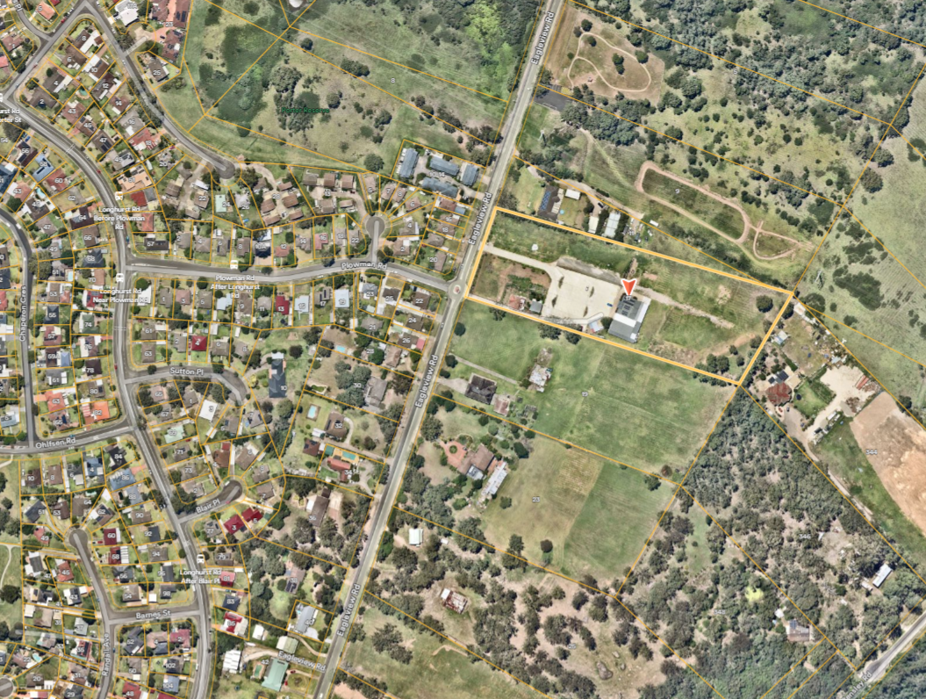

**The Site**

Figure 1 Subject site (source: Nearmap)

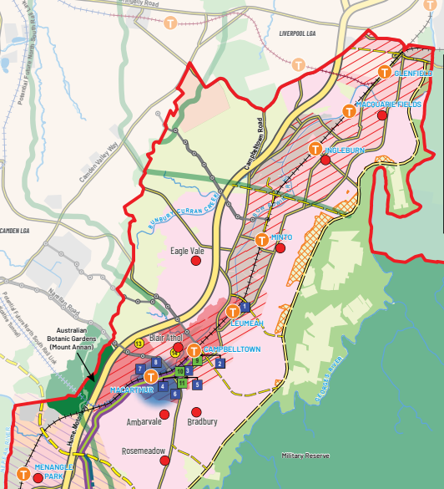

Figure 2 Site context

(source: Campbelltown LSPS)

The Site

## Mapping

The planning proposal includes mapping showing the proposed changes to the Additional Permitted Uses map, which is suitable for community consultation.

|  |  |
| --- | --- |
| Current Additional Permitted Uses Map | Proposed Additional Permitted Uses Map |
| 13-17 Eagleview Road, Minto |  |

Figure 3 Current and proposed additional permitted uses map

## Background

On 27 November 2023, a draft planning proposal was submitted to Council seeking an amendment to the Campbelltown LEP 2015 in relation to 13-17 Eagleview Road, Minto. The draft planning proposal seeks to amend the Campbelltown LEP 2015 and include ‘a place of worship’ as an additional permitted use to the site.

A development consent is currently issued for a community facility on the site, which was modified a number of times between 2012 and 2018. Under the current consent, specifically condition No. 6 prohibits the use of the site as a place of public worship, educational establishment, or any other land use not specified by that development consent.

In response to several complaints received by the Council, the use of the site was investigated, and evidence found that the site was being used as a place of public worship. Council issued a notice of proposed development control order (PDCO) stating that the site is under the C4 Environmental Living zone, and it prohibits the site being used as a place of public worship and/or for educational purpose.

On 22 May 2024, the planning proposal was considered by the Campbelltown Local Planning Panel (LPP) and the panel supported the proposal subject to traffic management, access and the residential amenity of the neighbouring properties being addressed.

On 10 December 2024, Council supported that the planning proposal would facilitate an important role to the local community and resolved to amend the Campbelltown LEP 2015 to include ‘a place of worship’ as additional permitted use under Schedule 1. Council also endorsed the planning proposal to proceed to Gateway Determination.

# Need for the planning proposal

The planning proposal is not a result of any strategic study or report. The planning proposal was prepared by the proponent to enable the site to be used as a place of public worship which is currently prohibited under the Campbelltown LEP 2015.

The planning proposal is the best way to achieve the intended outcomes and objectives as it is the simplest administrative way to achieve the aims of the planning proposal.

# Strategic assessment

## Regional Plan

The following table provides an assessment of the planning proposal against relevant aspects of the Greater Sydney Regional Plan: A Metropolis of Three Cities (March 2018).

Table 3 Regional Plan assessment

| Regional Plan Objectives | Justification |
| --- | --- |
| Objective 8 – Greater Sydne’s communities are culturally rich with diverse neighbourhoods | The site is currently used as a community centre and the planning proposal will support a growing community with culturally diverse neighbourhoods by allowing a place of public worship as an additional permitted use.  It will further provide local community and neighbourhoods with culturally rich and diverse opportunities. |

## District Plan

The site is within the Western City District and the Greater Sydney Commission released the Western City District Plan on 18 March 2018. The plan contains planning priorities and actions to guide the growth of the district while improving its social, economic and environmental assets.

The planning proposal is consistent with the priorities for infrastructure and collaboration, liveability, productivity, and sustainability in the plan as outlined below.

The Department is satisfied the planning proposal gives to the District Plan in accordance with section 3.8 of the *Environmental Planning and Assessment Act 1979*. The following table includes an assessment of the planning proposal against relevant directions and actions.

Table 4 District Plan assessment

| District Plan Priorities | Justification |
| --- | --- |
| Planning Priority W3  Providing services and social infrastructure to meet people’s changing needs | The planning proposal will allow a place of public worship to be located on the site to cater for the needs of the growing Muslim community which is one of the largest religious groups within Minto at 22.3 per cent.  It will provide greater opportunities to people and offer diverse religious gatherings and community activities. |
| Planning Priority W4  Fostering healthy, creative, culturally rich and socially connected communities | The site is already used as a community facility and the planning proposal will facilitate the additional function as a place of public worship. The planning proposal states the additional permitted use added to the existing community facility will directly contribute to the objectives and Planning Priorities, enabling stronger social bonds and engagement. |

## Local

The proposal states that it is consistent with the following local plans and endorsed strategies. It is also consistent with the strategic direction and objectives, as stated in the table below:

Table 5 Local strategic planning assessment

| Local Strategies | Justification |
| --- | --- |
| Campbelltown Community Strategic Plan – Campbelltown 2032 | The planning proposal is consistent with:   * Focus Area 1.1A Proud and inclusive community and strategies - 1.1.1 Provide initiatives that foster a proud, inclusive and connected community for all and 1.1.2 Provide a diverse range of cultural and creative activities and events for all interests and people. * Focus Area 2.1 Public spaces and facilities and strategy - 2.1.2 Provide public spaces and facilities that encourage leisure, recreation and physical activity. |
| Campbelltown Local Strategic Planning Statement | The Planning Proposal provides a sound justification for how it will align with priorities of the Campbelltown LSPS. From the Campbelltown LSPS, the proposal particularly gives effect to:   * *Priority 4 - Celebrating the arts and culture*   The planning proposal seeks for an additional permitted use as a place of worship applied to an existing community facility to provide the need for a growing Muslim community. It will allow community to gather and celebrate their culture and religion.   * *Priority 6 - Respecting and protecting our natural assets*   The southern eastern portion of the site contains a significant vegetation that has biodiversity value and mapped for conservation. The use of the site including the additional use as a place of public worship will have no direct impact on vegetation.   * *Priority 14: Ensuring infrastructure aligns with growth*   The planning proposal states the site already benefits from existing infrastructure. Additional information has been provided identifying that further work needs to be undertaken for the potential impact from increased traffic at the Plowman and Eagle View Road Intersection/roundabout during cultural events and on Fridays between 11am and 3pm.  The Campbelltown LSPS identifies the subject site as being a ‘Potential Transition Area’ and it defines as it’s the parcels of land zoned E4 Environmental Living (now C4 Environmental Living), where some modest reduction of lot size (2ha to 1ha) could be possible under the existing provisions of Campbelltown LEP 2015, subject to specified criteria being met.  The Planning proposal does not seek to make changes to the minimum lot size and the planning proposal states that community facility and potential use of the site as a place of public worship are appropriate for these type of larger lot sizes which would provide sufficient space for car parking and separation from neighbouring properties. |

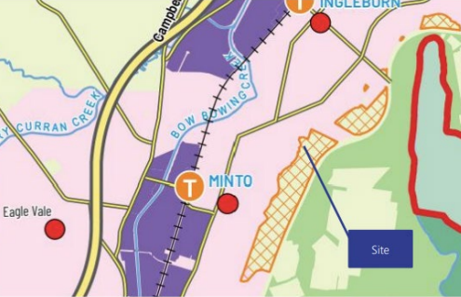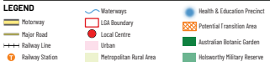

Figure 4 The subject site identified as ‘Potential Transition Area’ in Campbelltown LSPS (source: Planning Proposal)

## Local planning panel (LPP) recommendation

The planning proposal was reported to the Campbelltown Local Planning Panel on 22 May 2024 in accordance with requirements of Section 2.19 of the *Environmental Planning and Assessment Act 1979.*

The LPP was generally supportive of the proposal nothing there are three places of public worship that have historically been approved within the C4 Environmetal Living zone by way of additional permitted uses under Schedule 1 of the CLEP 2015. The LPP also noted that the planning proposal would provide a facility for the local community. However, it was recommended the proponent to provide further additional information to address potential impacts and the intensity and frequency of the use on the local area. Further justification should be provided that the C4 zone and the site in this case is appropriate and suitable for the use and to ensure there is site specific merit for the proposal. The additional information was provided to Council and Council officers recommended that Council endorses the planning proposal to proceed to a Gateway determination.

On 10 December 2024, Council at its meeting, supported the officers and LPP’s recommendation and endorsed the planning proposal to proceed to Gateway Determination.

## Section 9.1 Ministerial Directions

The planning proposal’s consistency with relevant section 9.1 Directions is discussed below:

Table 6 9.1 Ministerial Direction assessment

|  |  |  |
| --- | --- | --- |
| Directions | Consistent/ Not Applicable | Reasons for Consistency or Inconsistency |
| 1.1 Implementation of Regional Plans | Consistent | The planning proposal is consistent with this Direction as the proposal seeks to achieve the overall intent of the Regional Plan’s vision, land use strategy, goals and directions or actions. It particularly meets the Objective 8 – Greater Sydney’s communities are culturally rich with diverse neighbourhoods. |
| 1.4 Site Specific Provisions | Inconsistent of minor significance | The objective of this direction is to discourage unnecessarily restrictive site-specific planning controls. The planning proposal is inconsistent with this direction as it seeks to introduce a site specific clause (i.e. the additional permitted uses) in the Campbelltown LEP 2015. This proposal intends to allow the land use for the purpose of a ‘place of public worship’ to be carried out on the subject land zoned as C4 which would otherwise be a prohibited use in that zone.  The inconsistency is justified as of minor significance as the additional permitted use for ‘a place of public worship’ will address the religious and cultural needs of the community. |
| 3.1 Conservation Zones | Yes | The objective of this direction is to protect and conserve environmentally sensitive areas.  A small portion of the land in the south east corner of the site is mapped as ‘terrestrial biodiversity’ and contains threatened ecological community of the Cumberland Shale-Sandstone Ironbark Forest and core Koala Habitat (see **Figure 5**).  The planning proposal does not seek to intensify land use in that part of mapped area or propose any land clearing or remove vegetation therefore is consistent with this direction.  **Figure 5 Mapping of Biodiversity Values (source: NSW Planning Portal Spatial Viewer)** |
| 4.3 Planning for Bushfire Protection | Further justification required | The objectives of this direction are to protect life, property and the environment from bush fire hazards and to encourage sound management of bush fire prone areas.  The planning proposal applies to land that has been mapped as bushfire prone (see **Figure 6** below). The site contains Vegetation Category 3 and Vegetation Buffer.  A Bushfire Assessment Report (**Attachment F**) was prepared for the planning proposal and recommends Asset Protection Zones (APZ) from the building for 38m to the north, east and west and to the boundary to the south to be applied as outlined in *Planning* *for Bushfire Protection 2019*.  The existing community facility that is proposed to be used for the purpose of a place of public worship is located within Vegetation Buffer area. The areas around the existing building are proposed to be used for a variety of activities including a car park (west and north) along with social gatherings (east) and these areas will be maintained for uses which will achieve the requirements of the APZ and Inner Protection Area.  The planning proposal seeks to mitigate the bush fire hazards by increasing the distance of APZ. Also, the future use of the site will not create any inappropriate development/structures or adverse impact in hazardous areas. The planning proposal notes the site has been upgraded to provide a potable water connection and fire hydrants have been installed at the premises to ensure adequate water is supplied in case of fire.  Direction 4.3 requires consultation with NSW Rural Fire Service following Gateway determination for planning proposals affecting bushfire prone land. The Gateway determination includes a condition to this effect.  **Figure 6 Site outlined in Bushfire Prone Land map (source: NSW Planning Portal Spatial Viewer)** |
| 4.4 Remediation of Contaminated Land | Consistent | The objective of this direction is to reduce the risk of harm to human health and the environment by ensuring that contamination and remediation are considered by planning proposal authorities.  Direction 4.4 requires planning proposal authorities to consider the plan for land contamination risk.  The planning proposal states the site has previously been determined to be suitable for community facility uses and additional permitted use as a place of public worship will unlikely result in land contamination or hazardous type of development.  The planning proposal is consistent with the direction. |

## State environmental planning policies (SEPPs)

The planning proposal is consistent with all relevant SEPPs as discussed in the table below.

Table 7 Assessment of planning proposal against relevant SEPPs

|  |  |  |  |
| --- | --- | --- | --- |
| SEPPs | Requirement | Consistent/ Not Applicable | Reasons for Consistency or Inconsistency |
| SEPP (Biodiversity and Conservation) 2021 | Chapter 2 – Vegetation in non-rural areas  Chapter 4 – Koala habitat protection 2021 | Consistent | Chapter 2 applies to the planning proposal as the site is zoned C4 – Environmental Living. However, addition of a place of public worship as an additional permitted use to the site does not result in a clearing of native vegetation zoned for urban purposes.  Chapter 4 aims to encourage the conservation and management of areas of natural vegetation that provide habitat for koalas to support a permanent free-living population over their present range and reverse the current trend of koala population decline.  The planning proposal is not inconsistent with the SEPP. The planning proposal does not facilitate any intensification that can impact on the biodiversity of the site. |
| SEPP (Transport and Infrastructure) 2021 | Chapter 2 – Infrastructure | Consistent | This SEPP applies to facilitate an effective delivery of infrastructure across the State by identifying matters to be considered in the assessment of development adjacent to particular types of infrastructure development.  The additional permitted use as a place of public worship does not alter the operation of this SEPP. |
|  | | | |

# Site-specific assessment

## Environmental

The following table provides an assessment of the potential environmental impacts associated with the proposal.

Table 8 Environmental impact assessment

| Environmental Impact | Assessment |
| --- | --- |
| Biodiversity | The south eastern corner of the site is mapped as biodiversity land and contains potential koala habitat and threatened ecological community such as the Cumberland Shale-Sandstone Ironbark Forest.  The site is currently used as community facility and the proposed additional permitted use as a place of public worship is unlikely to create any adverse impact on the vegetation and potential koala habitat within the biodiversity mapped area.  However, future development applications would need to consider any impact on the biodiversity mapped area. |
| Bushfire | The site is identified within the Vegetation Category 3 and Vegetation Buffer of Bushfire Prone Land classification.  The proposal does not seek to modify the building footprint or intensify the density. However, the planning proposal states the increase in patronage on the site over an extended period would increase the risk to life.  The planning proposal seeks to mitigate the bush fire hazards by increasing the distance of the APZ. A Bushfire Assessment Report (**Attachment F**) was prepared for the planning proposal and recommends Asset Protection Zones (APZ) from the building for a distance of 38m be applied. Also, the future use of the site will not create any inappropriate development/structures or adverse impact in hazardous areas.  It is also noted, the site has been upgraded to provide a potable water connection and fire hydrants have been installed at the premises to ensure adequate water is supplied in case of fire.  It is recommended that a consultation with the NSW Rural Fire Service is required during the public exhibition. |
| Number of people attending the site | The proposal states that the site currently accommodate a maximum of 100 people for regular weekly activities and up to 220 people for larger events held on Fridays, Saturdays and Sundays, with no more than two gatherings per day and a minimum one hour gap between events. The maximum number of people are capped under the current development consent and the proposal does not propose to increase the number of people attending the site. The proposal comments that the operational impact of a place of public worship could be effectively managed through development consent conditions and a plan of management.  Any future development consent condition would include a possible cap on the maximum number of people attending the site and/or the number of cars allowed on site at any one time. This is not proposed to be changed for conditions imposed under the current development consent for the community facility use. |

## Social and economic

The following table provides an assessment of the potential social and economic impacts associated with the proposal.

Table 9 Social and economic impact assessment

| Social and Economic Impact | Assessment |
| --- | --- |
| Support social and cultural interaction | The planning proposal highlights the positive social impact by providing an additional land use that will enable a place of public worship to be permitted with consent. It will support social and cultural interactions of the growing Muslim community in Minto. |

## Infrastructure

The following table provides an assessment of the adequacy of infrastructure to service the site and the development resulting from the planning proposal and what infrastructure is proposed in support of the proposal.

Table 10 Infrastructure assessment

| Infrastructure | Assessment |
| --- | --- |
| Portable Water Connection and Fire Hydrants | The site has been upgraded to provide a potable water connection and fire hydrants have been installed at the premises to ensure adequate water is supplied in case of fire. |
| Traffic | The LPP and Council’s Traffic Engineers raised concerns on vehicles accessing the site and the vehicle spill onto the road in front of the site and the impact on traffic flows moving past the site at times of worship. This matter was investigated, and Traffic and Transport assessment identified further work would be required considering the impact of potential increased traffic at the Plowman Road and Eagleview Road intersection during cultural events and at times of worship on Fridays between 11am and 3pm.  Transport Assessment Report (**Attachment G**) provides an option for a redesign of the roundabout at Eagleview Road and Plowman which can improve local traffic circulation by preventing illegal vehicle turns, especially for vehicles travelling south to the site.  Further discussions and design options for traffic improvement be considered at the future development application stage. |
| Car parking | Under the current Council’s car parking policy, a community facility to cater for the maximum of 220 people on site requires 120 sealed car parking spaces. Comparably, a place of public worship to accommodate 220 people on site would require 63 spaces. The site currently provides 84 marked parking spaces including 4 accessible parking spaces and additional 20 informal parking spaces.  To avoid vehicle spilling onto the road, the proponent proposed an onsite plan of management during busy periods.  Further consideration is required at the development application stage. |

# Consultation

## Community

The planning proposal is categorised as a standard under the LEP Making Guidelines (September 2022). Accordingly, a community consultation period of 20 working days is recommended and this forms part of the conditions to the Gateway determination.

## Agencies

The proposal does not specifically raise which agencies will be consulted.

It is recommended the following agencies be consulted on the planning proposal and given 30 working days to comment:

* NSW Rural Fire Service
* Department of Climate Change, Energy, the Environment and Water
* Transport for NSW

# Timeframe

Council proposes a six (6) month time frame to complete the LEP.

The Department recommends an LEP completion date of eight (8) months in line with its commitment to reducing processing times and with regard to the benchmark timeframes. It is recommended that if the Gateway is supported it also includes conditions requiring council to exhibit and report on the proposal by specified milestone dates.

A condition to the above effect is recommended in the Gateway determination.

# Local plan-making authority

Council has advised that it would like to exercise its functions as a local plan-making authority.

As the site/planning proposal is standard amendment to the LEP, the Department recommends that Council be authorised to be the local plan-making authority for this proposal.

# Assessment summary

The planning proposal is supported to proceed with conditions for the following reasons:

* The planning proposal is the most appropriate way to achieve the objectives and intended outcomes
* The planning proposal has demonstrated potential strategic and site specific merit, subject to the recommended conditions and agency consultation.

Based on the assessment outlined in this report, the proposal proceeds with conditions.

# Recommendation

It is recommended the delegate of the Secretary:

* Agree that any inconsistency with section 9.1 Direction 1.4 Site Specific Provisions is minor or justified.
* Note that any inconsistency with section 9.1 Direction 4.3 Planning for Bushfire Protection is unresolved and will require consultation with RFS.

It is recommended the delegate of the Minister determine that the planning proposal should proceed subject to conditions:

1. Prior to public exhibition, consultation with the NSW Rural Fire Service is required in accordance with Section 9.1 Local Planning Direction 4.3 – Planning for Bushfire Protection.
2. The planning proposal should be made available for community consultation for a minimum of 20 days.
3. Consultation is required with the following public authorities:

* NSW Rural Fire Service
* Department of Climate Change, Energy, the Environment and Water
* Transport for NSW

1. The timeframe for completing the LEP is 30 November 2025.
2. Given the nature of the proposal, Council should be authorised to be the local plan-making authority.

C:\Users\chowc\AppData\Local\Microsoft\Windows\Temporary Internet Files\Content.MSO\4B9D4CC5.tmp20/3/2025

Chantelle Chow

Acting Director, Southern Western and Macarthur Regions

Local Planning & Council Support

Assessment officer

Sung Pak

Senior Planning Officer, Southern Western and Macarthur

8289 6755